Name – Atishay Jain
Registration no – 19BDS0033
NETWORK AND COMMUNICATION (LAB SLOT L25-L26)

Part A)

Activity-1 Execute the following commands with ANY FIVE additional options:

1. ifconfig)

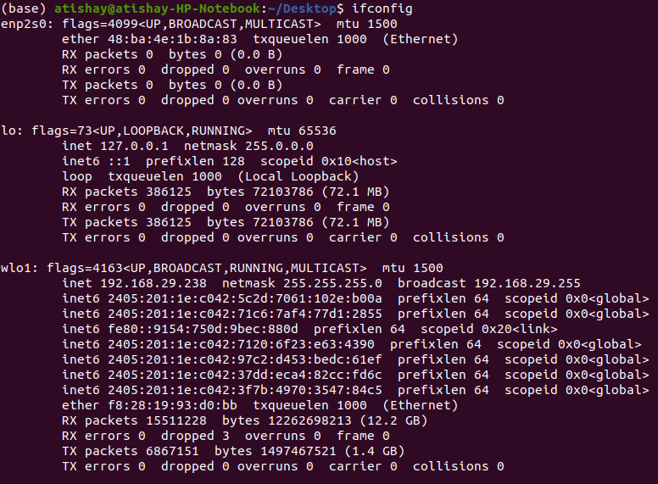
It will provide a complete description of the current state of all active network interfaces.

(i) -a
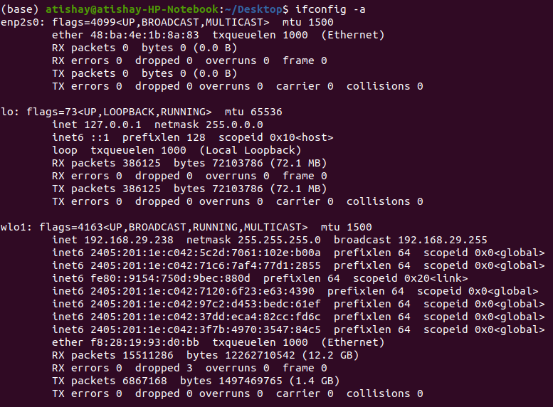
It will display all available interface details even if they are disable.

(ii) -s
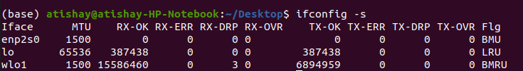
This shows a one-line summarized listing of data about each interface.

(iii) -v
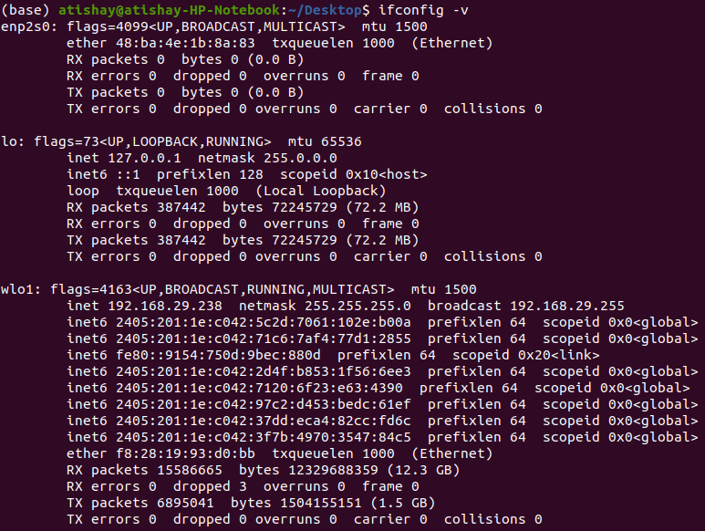

This "verbose" option returns extra information when there are certain types of error conditions to help with troubleshooting.

(iv) Up
This activates an interface if it is not already active

(v) Down
The counterpart to up, this deactivates the specified interface.

2. ping
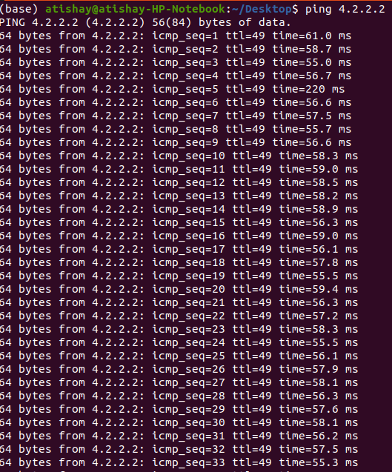

PING (Packet INternet Groper) command is the best way to test connectivity between two nodes.

(i) -c
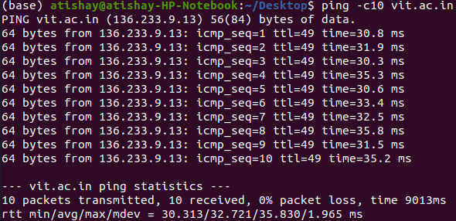
Ping with −c option exit after N number of request (success or error respond).

(ii) -i

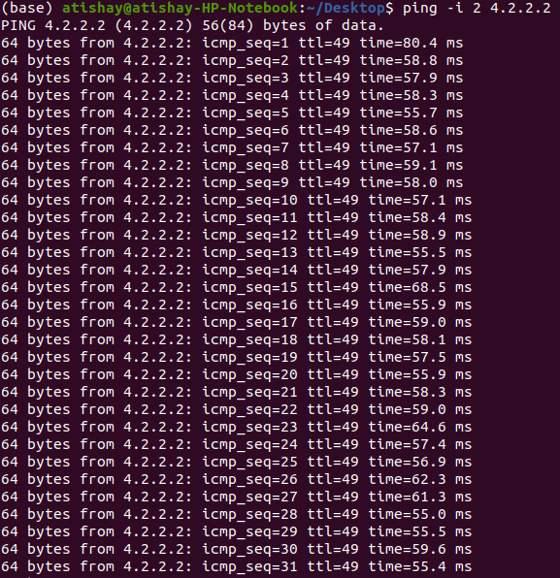
Use the -i option if you want a user-defined TTL for your ICMP echo request. The maximum is 255.

(iii) -l size
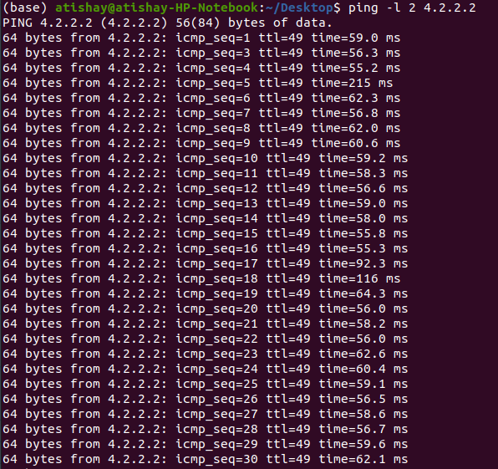
Use this option to set the size, in bytes, of the echo request packet from 32 to 65,527. The ping command will send a 32-byte echo request if you don't use the - l option.

(iv) -a
This ping command option will resolve, if possible, the hostname of an IP address target.

(v) -v

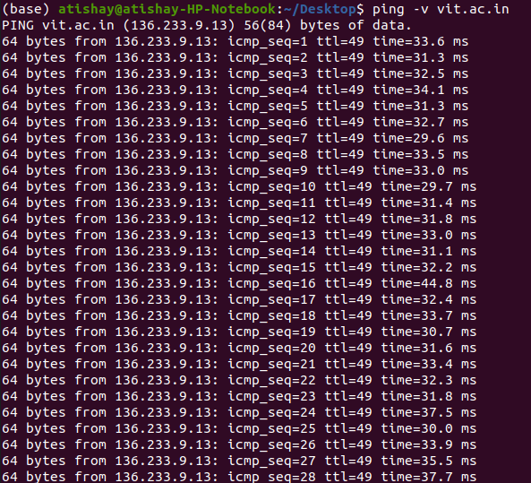
This would give more elaborate or verbose output

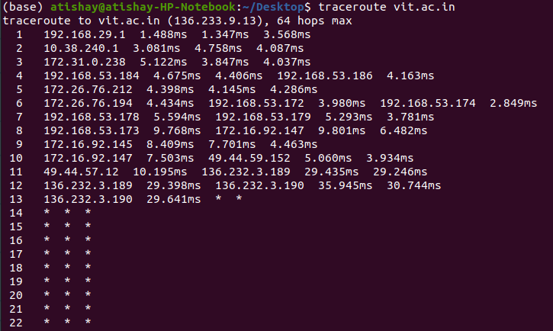
3. traceroute

It tells the number of hops taken to reach the destination and packets traveling path, it is used for troubleshooting.

(i) -w
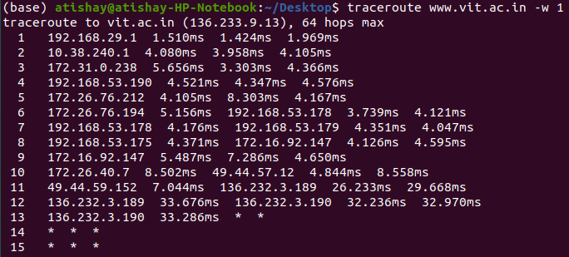

Configures response waiting time. It waits after issuing a probe. In this case the response time is one seconds.

(ii) -f

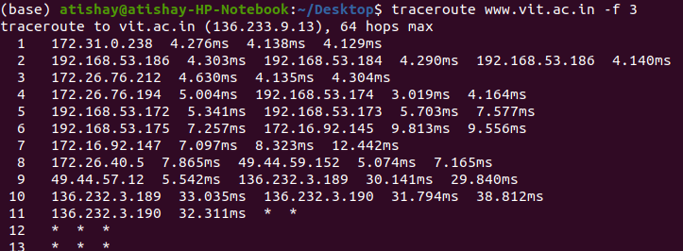

It configures the ttl value to start with

(iii) -q
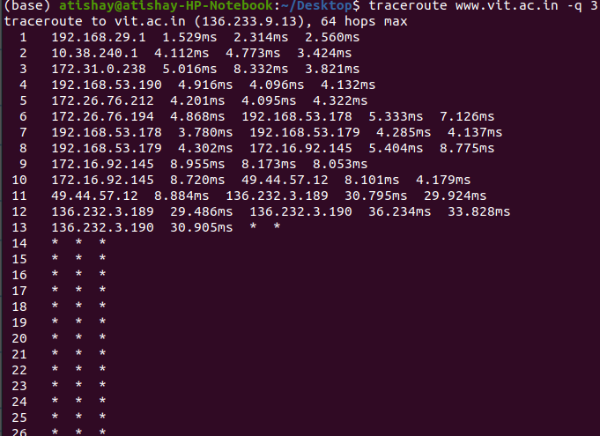
Configures the number of queries per hop

4. Netstat
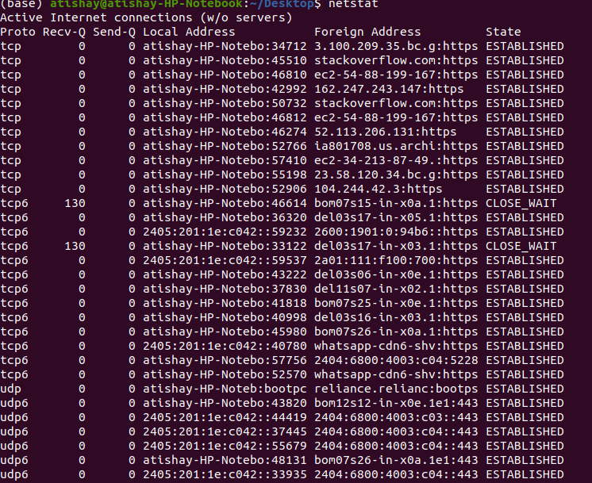

It delivers basic statistics on all network activities and informs users on which portsand addresses the corresponding connections (TCP, UDP) are running and which ports are open for tasks.

(i) -a
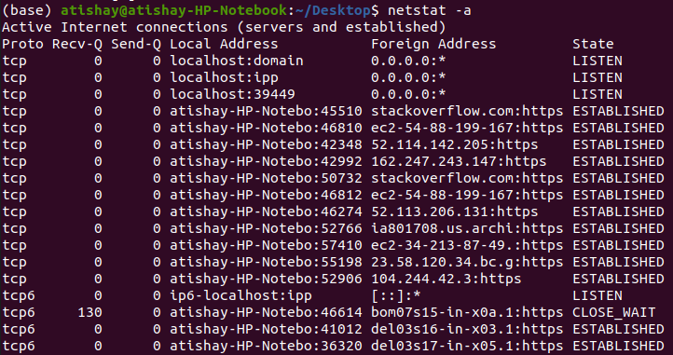
This command display all the active ports

(ii) -r
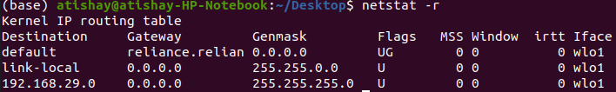
This displayes routing table

(iii) -i
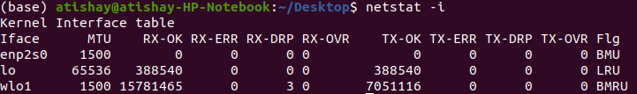
This displayes interface table

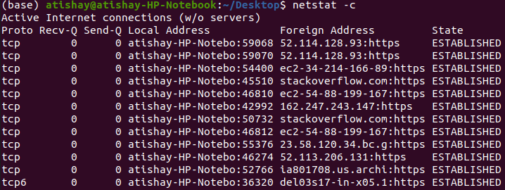
(iv) -c
Used for troubleshooting and configuration.

(v) -lu
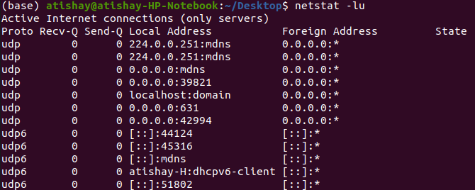
Shows only active udp ports with local and foreign address

5. nslookup
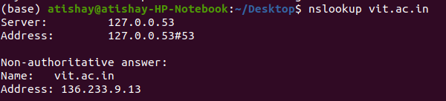
nslookup followed by the domain name will display the “A Record” (IP Address) of the domain. Use this command to find the address record for a domain. It queries to domain name servers and get the details

(i) -type = soa
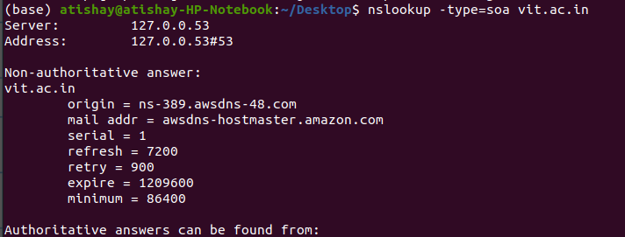
This tells us about the information of the zone and start of authority

(ii) -timeout
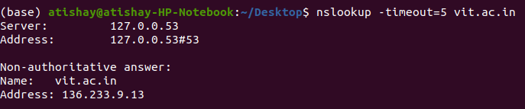
Using timeout we can manually decide the time in seconds to give more time to the server to respond by increasing it and check which server responds faster by shortening it.

(iii) -type = mx
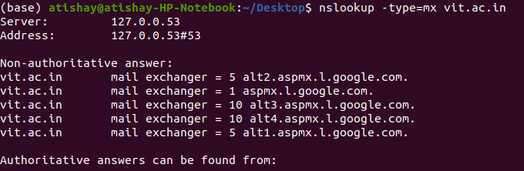
This check’s the MX records of the mail servers. You can see if all the mail servers are working well.

(iv) -debug

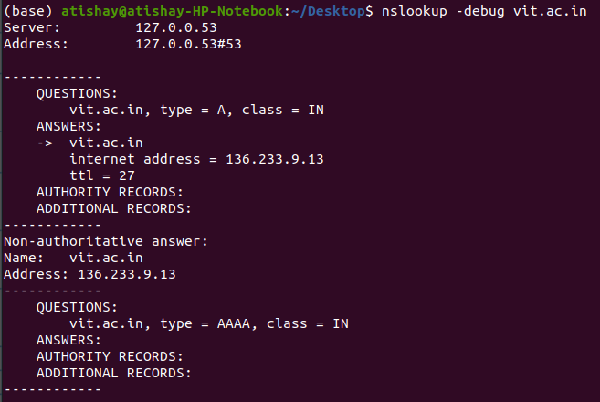
Debug mode provides important and detailed information both for the question and for the received answer

(v) -type=ns

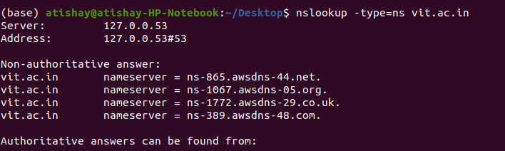
This gives us the ns record.

PART B

Activity-2

Q3)

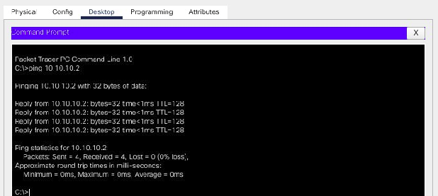

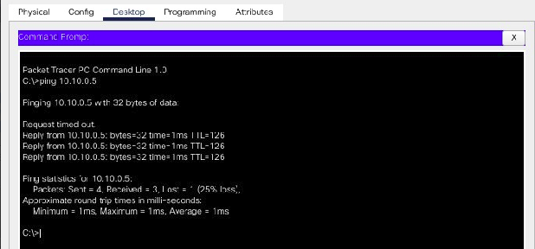

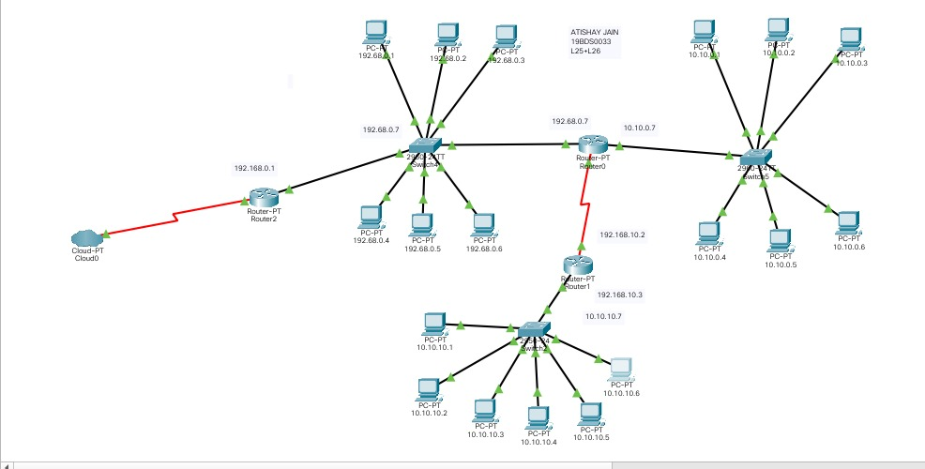

For connections between switches and PC’s use copper straight-through
For connections between switch and switch use copper cross-over
For connections between switch and router use copper straight-through
For connections between router and router use Serial DTE
For connection between cloud and router use Serial DTE

For switches
->Network devices
->switches
-> 2960-24 model
For Pc’s
->end devices
->Pc
For routers
->Network Devices
->routers
->2811 model
TALANKI SUBBA PRANAV KUMAR
19BDS0060
For Connections
->connections
For cloud
->Network Devices
->WAN emulation
->PT cloud

Q4)

